ASSIGNMENT 7

**Submitted by: Princepreet Singh**

COMPUTER ILLUSTRATION

**Explain free form text boxes and linked text boxes. How can you integrate them with columns to create a more complex document?**

**FREE FORM TEXT BOXES:**

It is a text box that can be drawn for any shape rather than a rectangular box, we can embed text in it. These specially shaped boxes can be used like any other text box.

**LINKED TEXT BOXES:**

When a text is too long for the box that contains it, it is possible to create a new box containing the rest of the text by first clicking on the small red box, then by drawing a new box. We will then notice a line connecting the end of the first box to the beginning of the second. we can also draw a new empty text box and link the two boxes together by clicking first the small red box of the first, then the second box a chain will appear near the mouse tip to indicate the linkable area.

In other words, if we type more text than will fit in a defined text box, an almost impossibly tiny plus (+) sign appears in the lower-right corner of the text box, as shown below. Overflow text can be continued in linked text boxes.

 The overflow text icon indicates that there is more text than fits in the text box.

**HOW TO INTEGRATE LINK TEXT BOXES:**

The basic routine for linking text boxes is to select both the original (overflowing) text box and another shape (any shape) and link the two objects. We can then flow text from one shape into another. The following steps will walk us through that process.

To link two text boxes, follow these steps:

1. Start by using the Type tool to draw a text box about 1 inch square. After we have drawn the box, type enough text to fill the square.
2. Keep typing. As we enter more text than the text box can hold, we won’t see the text, but Illustrator will store it and it will be available for a linked text box.
3. After we have typed more text than our text box will hold, we will notice the tiny plus sign on the right side of the text box.
4. Use any tool to create an additional closed path or shape, as shown below.

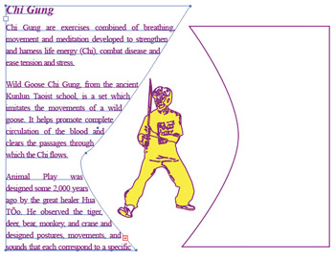  
 Preparing a text box to flow text into

1. Use the Selection tool to select both the original text box and the new shape.
2. Select Type Threaded Text Create. Text will flow from the text box into the new shape, as shown below.

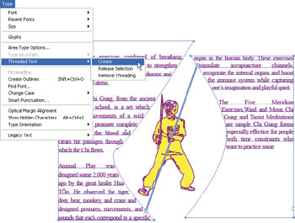  
Flowing text from one box into another